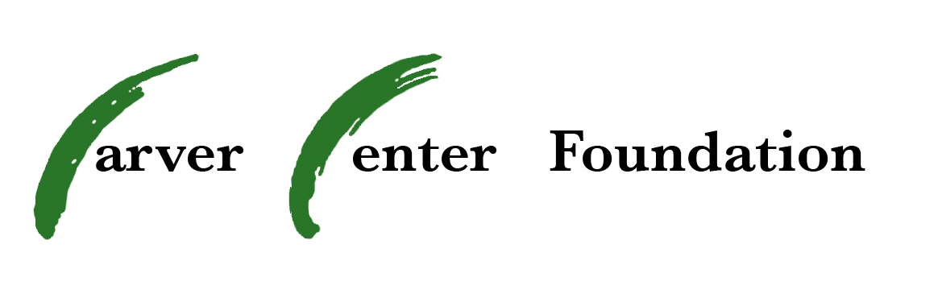

Grant/Disbursement Form

Instructions:

1. Complete and submit this form to your Department Chair, and then Carver Center’s principal for “school” approval. The principal will then pass the form on to the Foundation for approval.
2. The Foundation or the principal will inform the requesting faculty member of grant approval status.

3. Upon grant request approval, the faculty member should initiate purchase and forward receipts or invoices to Carver Center Foundation as per payment method chosen.

4. Please note the Grant Request Schedule, so that your grant can be considered in a timely manner.

5. Please fill in all areas so we can process your request promptly.

6. Please look ahead in the school year and submit requests as early as possible to avoid the possibility of funds being unavailable from the Foundation later in the year.

7. For academic courses, primes, clubs and other groups in which it might be anticipated that students will be participating in local, state, regional and/or national conferences or competitions, please attempt to consider funding needs for all such possibilities and make one overall grant request, so that the Foundation can consider the total that may need to be expended for any one set of conferences and competitions.

DO NOT COMMIT TO ANY EXPENSES BEFORE RECEIVING FOUNDATION APPROVAL.

For Board Use Only
Dept. Chair approval & certification that funds are not otherwise available
Principal’s approval & certification that funds are not otherwise available
Board Approval Yes _____ No _____ | Reason for Denial:
Foundation Signature: | Restricted Funds___ Unrestricted Funds____

Purpose of the Grant:

(Please elaborate below and/on a separate sheet to explain how this grant will support implementation of BCPS curriculum (where applicable) and improve student achievement. Additionally, provide verification that funds are not otherwise available and describe other ways money has been or will be raised for this purpose, i.e. fundraisers, other grant money. Attach any other additional information that may assist the Foundation in making its decision.)

Dollar Amount: ________________ Date: _______________

Requested by: __________________

Department: ___________________ Date funds needed: ___________

Number of Students Impacted _______ Number of Staff Impacted _____

Vendor information:

_____BCPS has a low bid on this item. I am required to use the vendor whose quote/information is attached to this request.

_____BCPS does not require the use of a specific vendor. I have attached at least 2 price quotes to this request.

Payment method: (check one)
_____ I will forward the invoice so the Foundation can pay vendor directly.

_____ I will instruct the vendor to send the invoice to the Foundation once delivery is complete

_____ Carver Center will pay vendor and send invoice to the foundation for reimbursement

Requestor’s signature and date:__________________________________

Department Chair signature and date:____________________________

Principal signature and date:____________________________________

